**MINOR PROJECT REPORT**

**ON**

**DICE ROLLING SIMULATOR**



**BACHELOR OF ENGINEERING**

**In**

**Computer Science and Engineering**

**SUBMITTED BY:**

**Group no.- 1(G6)**

**Riya Gupta (2020A1R181)**

**Anchal Baghat (2020A1R187)**

**Swasti Gupta (2020A1R191)**

**Shrifal Raina (2020A1R177)**

**Model Institute of Engineering and Technology**

**Kot Bhalwal, Jammu - 181122**

**Contents**

| S.NO. | TOPICS |
| --- | --- |
| 1. | What isDice Rolling Simulator |
| 2. | What is Tkinter |
| 3. | What is GUI (Graphical User Interface) |
| 4. | Steps to create a Dice Rolling Simulator with output |
| 5. | References |

**What is a Dice Rolling Simulator?**

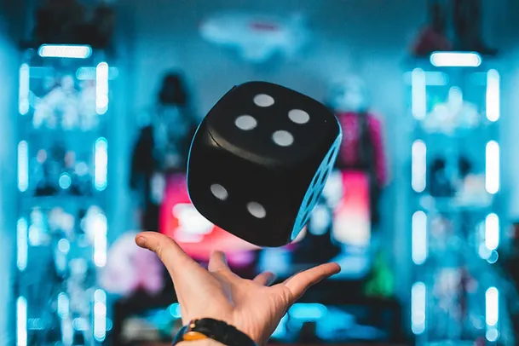

The Dice is a simple cube shaped like object used in various board games such as snake- ladder, Ludo etc. It is a simple cube which generates a random number when rolled by a user. A Dice rolling simulator is nothing but a computer model that can be created by a software program and it functions the same as a normal dice in which the user rolls a dice and a random number gets shown on the screen. There are many ways a dice simulator can be implemented. In this paper, we will implement a GUI Application of dice simulator using Tkinter Framework in Python.

## 

**What is Tkinter?**

Python has various frameworks/packages which can be used for making GUI applications i.e., the Graphical User Interface. Tkinter is the standard GUI package for Python. It is the most common, fast, and easy way to create a GUI (Graphical User Interface) application. It provides a powerful object-oriented interface to the Tk GUI toolkit. We can develop an application and can use that application on any platform, which reduces the need for additional requirements required to use an application on any OS like Windows, Mac, or Linux.

**What is GUI (Graphical User Interface)?**

The Graphical User Interface (GUI) is a form of user interface which allows a user to interact with electronic devices with the help of graphical icons and visual components. It displays objects that conveys information, and displays actions performed by the user.

**Dice Rolling Simulator Project in Python with Source Code**

* **Step 1:** **Importing the required module**

We will import the following modules:

* Tkinter: Imported to use Tkinter and make GUI applications.
* Image, Imagetk: Imported from PIL, i.e. Python Imaging Library. We use it to perform operations involving images in our UI.
* Random: Imported to generate random numbers.

*Code:*

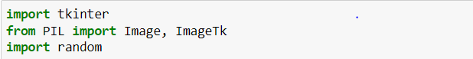

* **Step 2:**  **Building a top-level widget to make the main window for our application**

In this step, we will build the main window of our application, where the buttons, labels, and images will reside. We also give it a title by title() function.

*Code:*

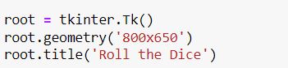

*Explanation:*

The above code sets the title of the application window as ‘ Roll the Dice’. Running the above code will generate a blank window of a dice rolling simulator python project with the title on it.

* **Step 3: Designing the buttons**

The below code will add a label giving a heading to our dice simulator. Also, we will add an image area, which will display the image chosen by random numbers.

*Code:*

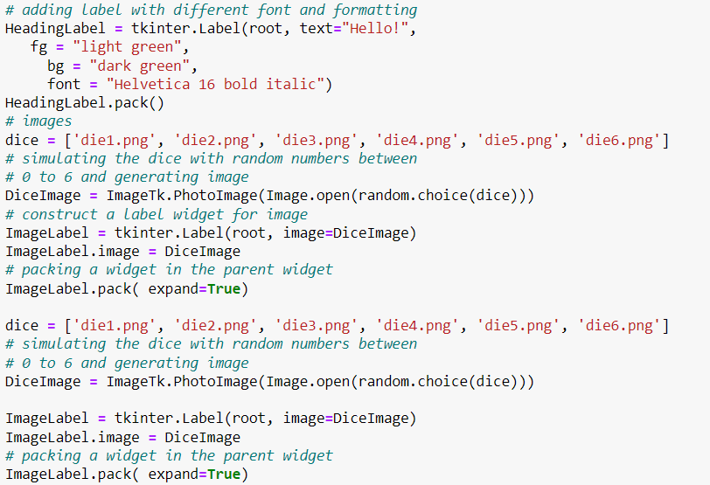

*Explanation:*

Here, we use pack() to arrange our widgets in row and column form. The ‘BlankLine’ label is to skip a line, whereas we use the ‘HeadingLabel’ label to give a heading.

* root – the name by which we refer to the main window of the application
* text – text to be displayed in the HeadingLabel
* fg– the colour of the font used in HeadingLabel
* bg – background colour of the HeadingLabel
* font – used to give customised fonts to the HeadingLabel text
* .pack() – Used to pack the widget onto the root window
* **Step 4: Forming a list of images to be randomly displayed**

*Code:*

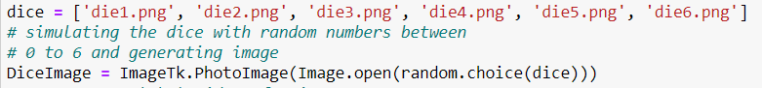

*Explanation:*

‘dice’ is the list of names of images kept in the same folder, which are chosen randomly according to the random number generated.

‘DiceImage’ is used to store an image of dice which is chosen by randomly generated numbers.

* **Step 4: Constructing a label for image, adding a button and assigning functionality**

*Code:*

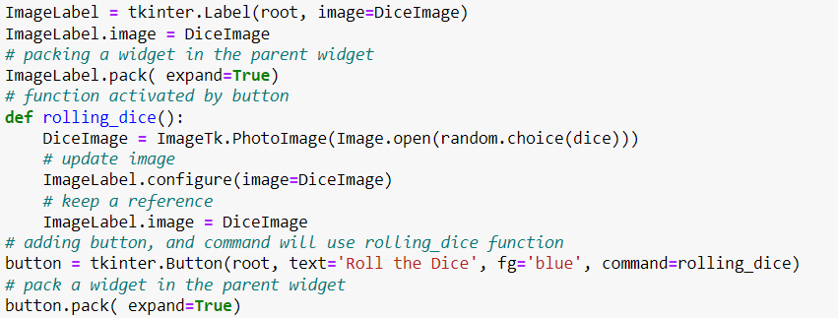

*Explanation:*

‘ImageLabel’ is to place an image in the window. The parameter expands declared as True so that even if we resize the window, the image remains in the center.

Major function:

‘rolling_dice’ function is a function that is executed every time a button is clicked. This is attained through the ‘command=rolling_dice’ parameter while defining a button.

* **Step 6: Forming a list of images to be randomly displayed**

*Code:*

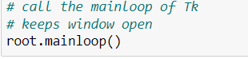

*Explanation:*

‘root.mainloop()’ is used to open the main window. It acts as the main function of our program.

**Dice Rolling Simulator Python Output**

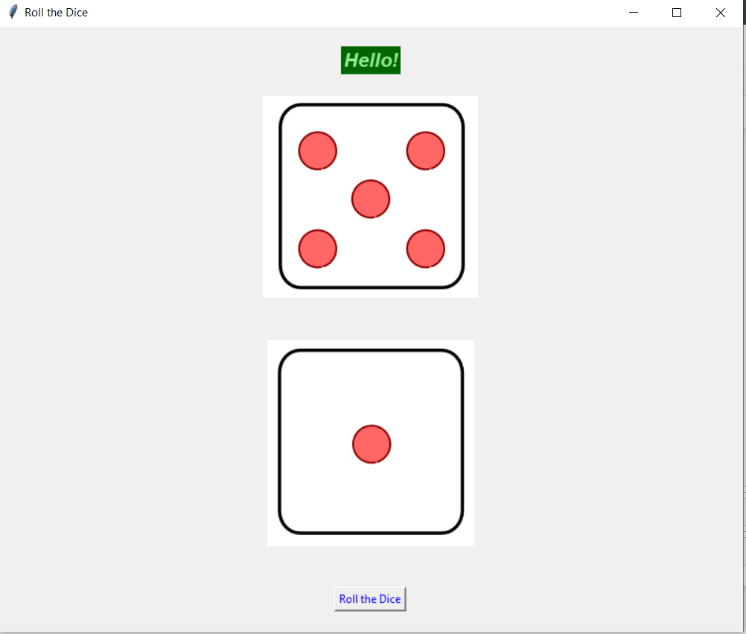

**References:**

* https://en.wikipedia.org/wiki/Tkinter
* https://www.tutorialspoint.com/python/python_gui_programming.htm
* https://www.w3schools.com/python/ref_random_choice.asp
* https://data-flair.training/blogs/dice-rolling-simulator-python/
* https://pillow.readthedocs.io/en/stable/reference/ImageTk.html
* http://clipart-library.com/dice-faces.html

## 

## **Hotel Management Python Code**

class hotelfarecal:

def __init__(self,rt='',s=0,p=0,r=0,t=0,a=1800,name='',address='',cindate='',coutdate='',rno=101):

print ("\n\n*****WELCOME TO HEWING HOTEL*****\n")

self. rt=rt

self.r=r

self.t=t

self.p=p

self.s=s

self.a=a

self.name=name

self. address=address

self. cindate=cindate

self. coutdate=coutdate

self.rno=rno

def inputdata(self):

self.name=input ("\nEnter your name:")

self. address=input("\nEnter your address:")

self. cindate=input ("\nEnter your check in date:")

self. coutdate=input ("\nEnter your checkout date:")

print("Your room no.:",self.rno,"\n")

def roomrent(self): #sel1353

print ("We have the following rooms for you: -")

print ("1.  type A---->rs 6000 PN\-")

print ("2.  type B---->rs 5000 PN\-")

print ("3.  type C---->rs 4000 PN\-")

print ("4.  type D---->rs 3000 PN\-")

x=int (input ("Enter Your Choice Please->"))

n=int (input ("For How Many Nights Did You Stay:"))

if(x==1):

print ("you have opted room type A")

self. s=6000*n

elif (x==2):

print ("you have opted room type B")

self. s=5000*n

elif (x==3):

print ("you have opted room type C")

self. s=4000*n

elif (x==4):

print ("you have opted room type D")

self. s=3000*n

else:

print ("please choose a room")

print ("your room rent is = “, self. s,"\n")

def restaurentbill(self):

print ("*****RESTAURANT MENU*****")

print ("1. water----->Rs20","2. tea----->Rs10","3. breakfast combo--->Rs90","4. lunch---->Rs110","5. dinner--->Rs150","6. Exit")

while (1):

c=int (input ("Enter your choice:"))

if (c==1):

d=int (input ("Enter the quantity:"))

self.r=self.r+20*d

elif (c==2):

d=int (input ("Enter the quantity:"))

self.r=self.r+10*d

elif (c==3):

d=int (input ("Enter the quantity:"))

self.r=self.r+90*d

elif (c==4):

d=int (input ("Enter the quantity:"))

self.r=self.r+110*d

elif (c==5):

d=int (input ("Enter the quantity:"))

self.r=self.r+150*d

elif (c==6):

break;

else:

print ("Invalid option")

print ("Total food Cost=Rs”, self.r,"\n")

def laundrybill(self):

print ("******LAUNDRY MENU*******")

print ("1. Shorts----->Rs3","2. Trousers----->Rs4","3. Shirt--->Rs5","4. Jeans---->Rs6","5. Girlsuit--->Rs8","6. Exit")

while (1):

#brought to you by code-projects.org

e=int (input ("Enter your choice:"))

if (e==1):

f=int (input ("Enter the quantity:"))

self.t=self.t+3*f

elif (e==2):

f=int (input ("Enter the quantity:"))

self.t=self.t+4*f

elif (e==3):

f=int (input ("Enter the quantity:"))

self.t=self.t+5*f

elif (e==4):

f=int (input ("Enter the quantity:"))

self.t=self.t+6*f

elif (e==5):

f=int (input ("Enter the quantity:"))

self.t=self.t+8*f

elif (e==6):

break;

else:

print ("Invalid option")

print ("Total Laundary Cost=Rs",self.t,"\n")

def gamebill(self):

print ("******GAME MENU*******")

print ("1. Table tennis----->Rs60","2.Bowling----->Rs80","3.Snooker--->Rs70","4.Video games---->Rs90","5.Pool--->Rs50==6","6.Exit")

while (1):

g=int (input ("Enter your choice:"))

if (g==1):

h=int (input ("No. of hours:"))

self.p=self.p+60*h

elif (g==2):

h=int (input ("No. of hours:"))

self.p=self.p+80*h

elif (g==3):

h=int (input ("No. of hours:"))

self.p=self.p+70*h

elif (g==4):

h=int (input ("No. of hours:"))

self.p=self.p+90*h

elif (g==5):

h=int (input ("No. of hours:"))

self.p=self.p+50*h

elif (g==6):

break;

else:

print ("Invalid option")

print ("Total Game Bill=Rs”, self.p,"\n")

def display(self):

print ("******HOTEL BILL******")

print ("Customer details:")

print ("Customer name:”, self.name)

print ("Customer address:”, self. address)

print ("Check in date:”, self. cindate)

print ("Check out date”, self. coutdate)

print ("Room no.”, self.rno)

print ("Your Room rent is:”, self.s)

print ("Your Food bill is:”, self.r)

print ("Your laundary bill is:”, self.t)

print ("Your Game bill is:”, self.p)

self. rt=self. s+self.t+self.p+self. rt

print ("Your sub total bill is:",self.rt)

print ("Additional Service Charges is”, self.a)

print ("Your grandtotal bill is:”, self.rt+self.a,"\n")

self.rno+=1

def main ():

a=hotelfarecal ()

while (1):

print ("1. Enter Customer Data")

print ("2. Calculate rommrent")

print ("3. Calculate restaurant bill")

print ("4. Calculate laundry bill")

print ("5. Calculate gamebill")

print ("6. Show total cost")

print ("7. EXIT")

b=int (input ("\nEnter your choice:"))

if (b==1):

a. inputdata ()

if (b==2):

a. roomrent ()

if (b==3):

a. restaurentbill ()

if (b==4):

a. laundrybill ()

if (b==5):

a. gamebill ()

if (b==6):

a. display ()

if (b==7):

quit( )

main()

**OUTPUT**

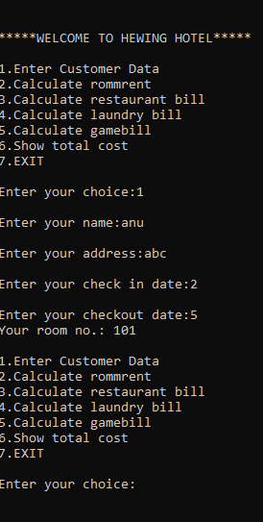

**REFERENCES**

* [Hotel Management System Project In Python With Source Code (itsourcecode.com)](https://itsourcecode.com/free-projects/python-projects/hotel-management-system-project-in-python/#:~:text=Steps%20on%20how%20to%20create%20a%20Hotel%20Management,...%204%20Step%204%3A%20The%20actual%20code.%20)
* [What Is Hotel Management? Definition and Duties | Indeed.com](https://www.indeed.com/career-advice/finding-a-job/hotel-management)